Mimics to develop stl from CT dicom file

* File -> new project wizard
* Load dicom data
* Threshold (button on the top bar) 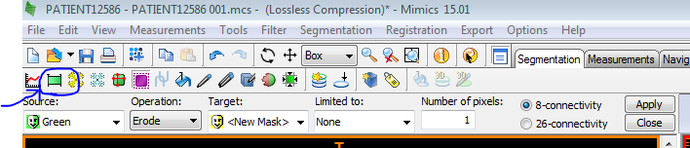
  + Threshold high ~900-3000 so just the part you’re interested in is highlighted (not any residuals). The mask should look like: 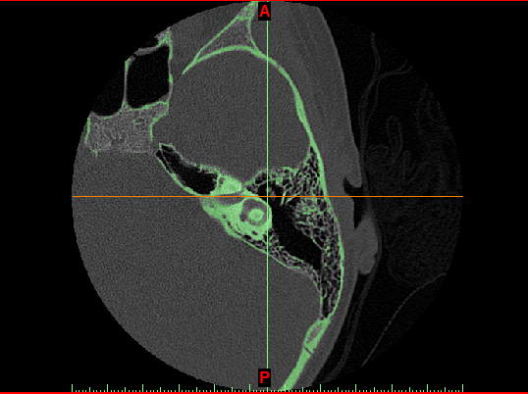
* Right click on the mask on the right bar -> Morphology Operations

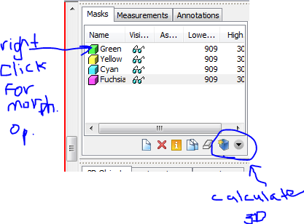

* + Ensure your mask is selected
  + Dilate: select number of pixels – dilates the thresholded region
  + Erode: select number of pixels – erodes parts of the region
  + On the right bar -> calculate 3D model
* Now you have a smooth model but it is missing information because of the dilate
* Edit mask:

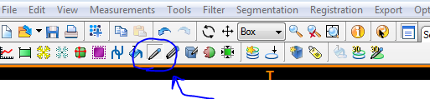

* + Select threshold
    - High range to recover air pockets
    - Low range (~2-3000) to recover structures that were hidden

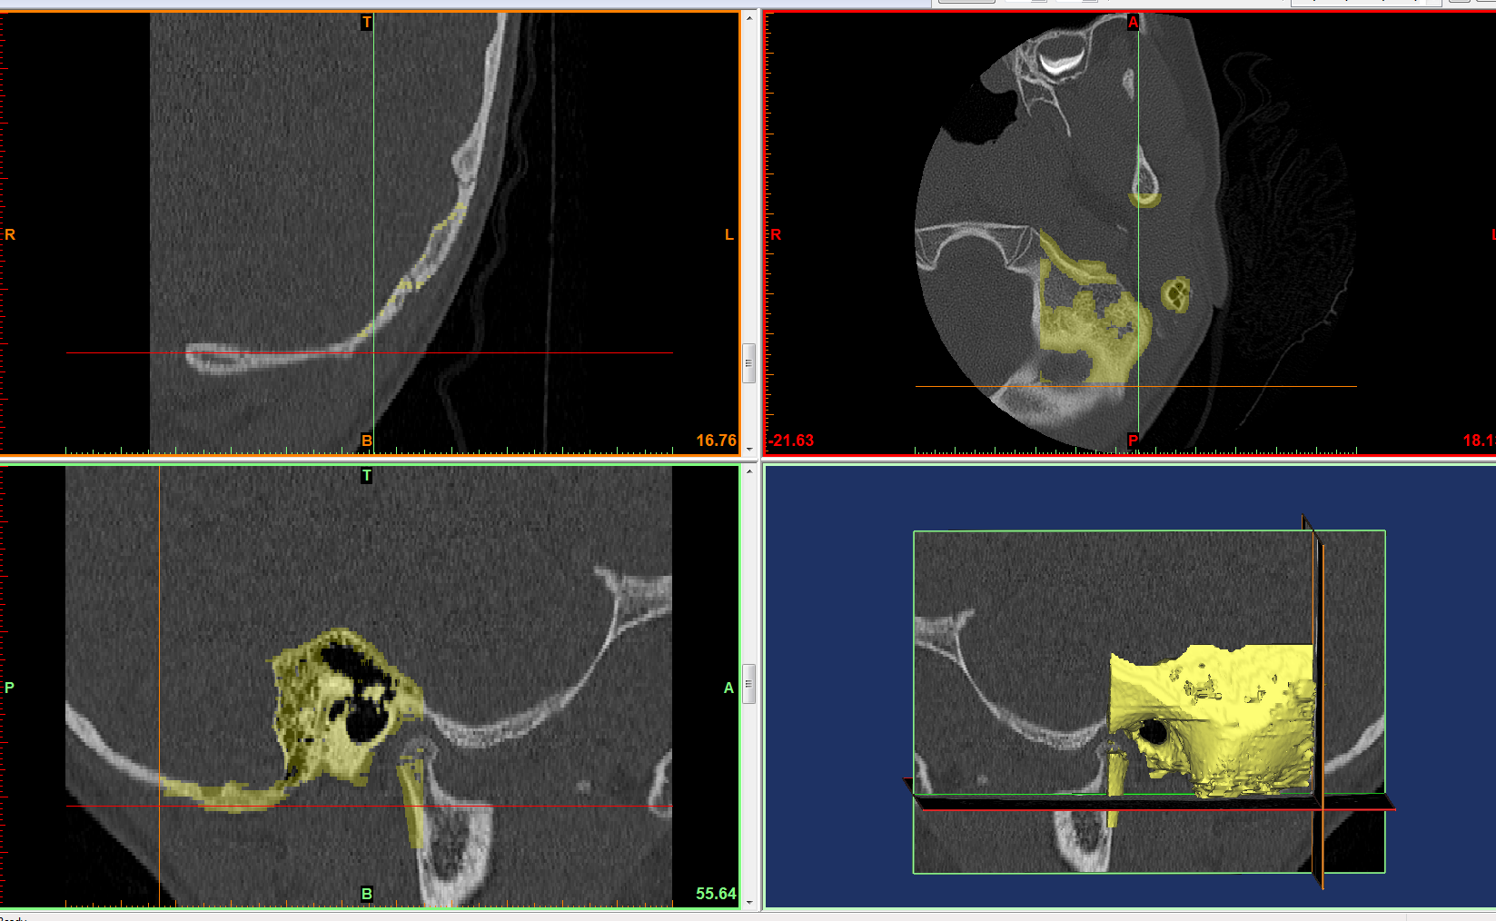

Bottom left shows the ear canal on the scan , bottom right shows the ear canal

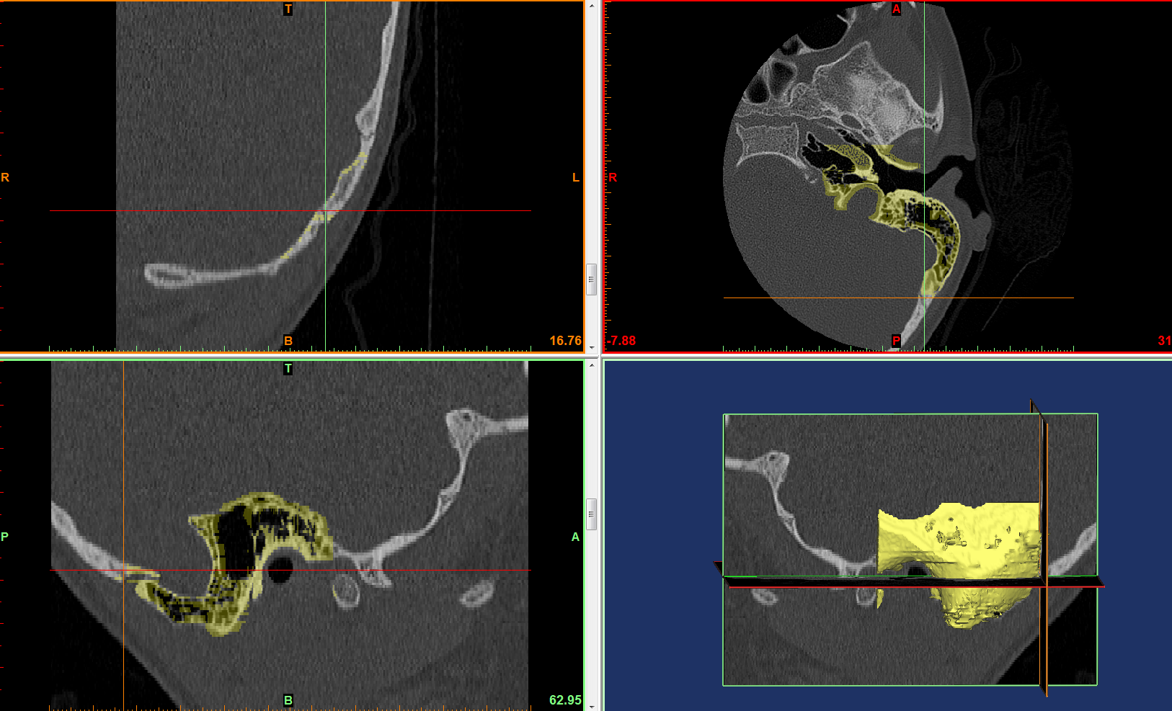

Arrows are pointing to the ear canal – goal is to use the edit mask tool to paint and select the regions with desired threshold

Only are worried about the ear canal as that is where the endoscope and instruments will go through

3D printing of ear model:

V-1 16-Nov-2016:

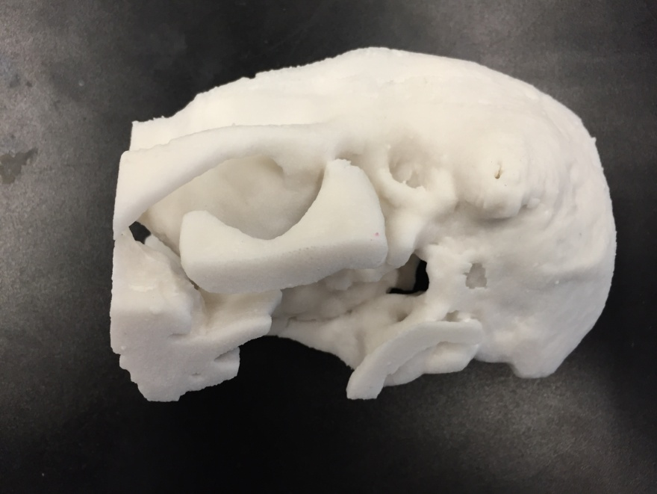

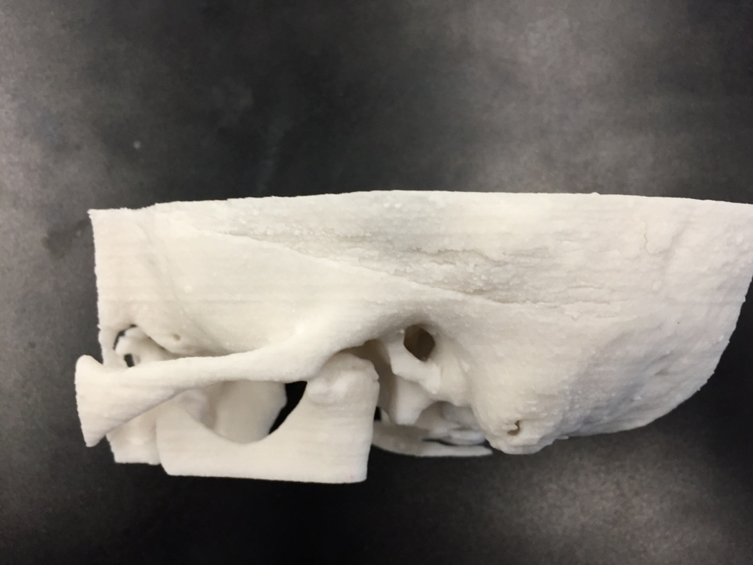

Feedback from Dr. James: Features were blurry – ossicles not visible, usable but not accurate

V-2 22-Nov-2016:

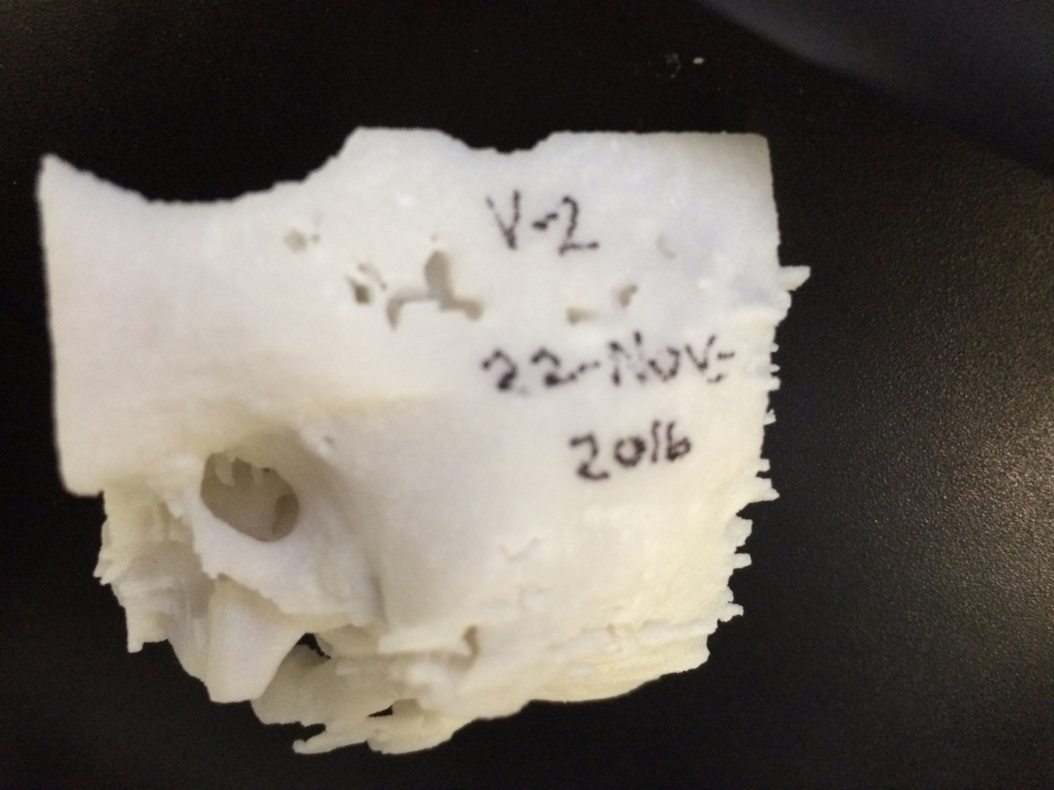

This one showed enough resolution for the hearing bones

Will test with endoscope

Good enough resolution

Keep the wall on top with holes in it because it allows us to see if the instruments are reaching areas from outside

The bone there is paper-thin anyway

Literature Search on Temporal Bone Models:

* 3D printed ABS temporal bone model

Virtual Model:

Integrating anatomy, tool, endoscope

Feb-2017: Took slices of model but it is hard to orient because need a reference (ie. Ossicles)

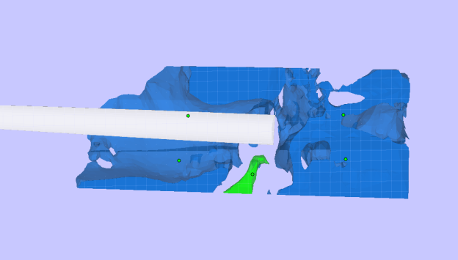

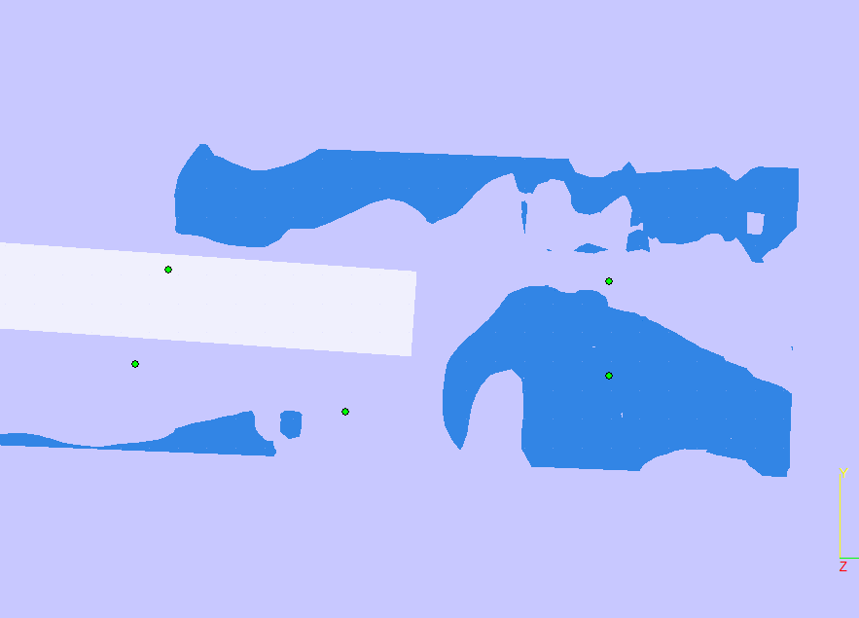

instruments should reach areas that of endoscope`s field of view.

“comparison of middle ear visualization with endoscopy and microscopy” (1)

* Built a 3D model of the ear space using VTK-based interactive segmentation editing software developed in the lab
* 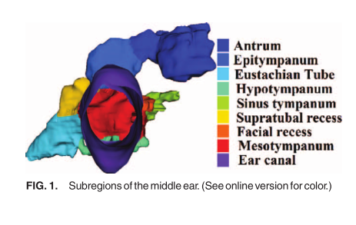
* Identify the 3D region defining the volume of space reachable by scope lens and range of angles at which scope could be oriented

Motivation for creating 3D models:

* Used to help surgeons in training (residents and fellows) learn techniques and can reproduce anatomy that may be tricky to help increase their skill, and handle difficult cases
* Cheaper way to practice than using cadaver, even though it can’t pick up soft tissue, it gives the bony anatomy and that would be useful to practice reaching places without having to drill, etc.
* Cheap way to test instruments and figure out what instruments would be good to perform the procedure in that patient (patient-specific surgical plan)
* Helpful to design new instruments’ geometry and size and visualize how the endoscope and instrument can move through anatomy

Creating temporal bone model: (2) – reference gives the steps I follow to create a model from CT scans

* CT scan -> threshold intensity levels are unique for each patient to isolate bone -> post processing of model consists of a 3D surface mesh -> smooth using Gaussian filter with std dev of 0.8mm and max approximation error of 0.03mm, optimal balance between a smooth surface and high enough resolution
* This paper also selected ossicles using manual segmentation (human judgement) because CT scan quality not high enough for automatic segmentation
* Rates the models by commenting on whether certain important structures are visible or not

(3) used mimics to create STL of bony anatomy + soft tissue structures -> printed on printer -> asked otolaryngologists to fill out a likert scale on how accurate the models were to real anatomy

14-Feb-2017:

* Modeling the air space – used mimics at negative threshold value and made a model for the air space surrounding superior region of malleus
* Will do the same for sinus tympani in another model
* Then make a model of just the air space

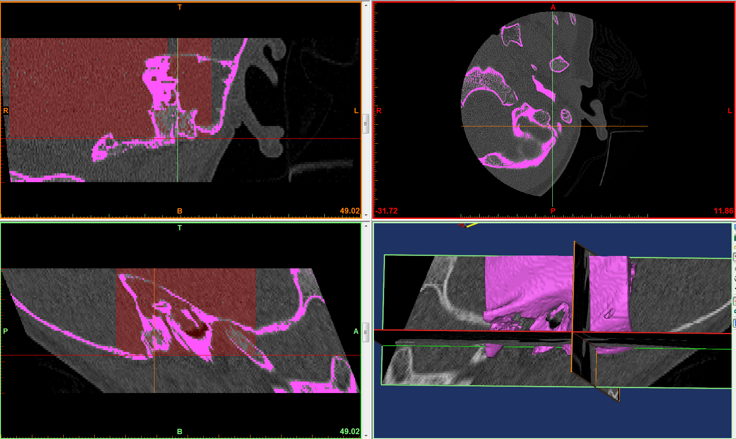 fuschia is a temporal bone mask made into the 3d model

Red is a negative threshold mask for soft tissue and air so use edit mask with a threshold paintbrush to deselect all the red except for inside the ear canal to get the following:

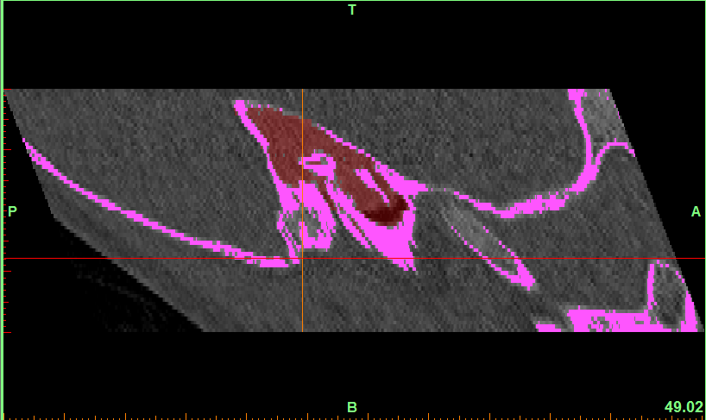

1. Bennett ML, Zhang D, Labadie RF, Noble JH. Comparison of Middle Ear Visualization With Endoscopy and Microscopy. Otol Neurotol. 2016;37:362–6.

2. Cohen J, Reyes SA. Creation of a 3D printed temporal bone model from clinical CT data. Am J Otolaryngol - Head Neck Med Surg [Internet]. Elsevier Inc.; 2015;36(5):619–24. Available from: http://dx.doi.org/10.1016/j.amjoto.2015.02.012

3. Rose AS, Kimbell JS, Webster CE, Harrysson OLA, Formeister EJ, Buchman CA. Design of a 3D Model for Temporal Bone Surgical Simulation. 3342.